UNIVERSITY OF CAPE COAST

COLLEGE OF AGRICULTURE AND NATURAL SCIENCES

SCHOOL OF PHYSICAL SCIENCES

**DEPARTMENT OF COMPUTER SCIENCE AND INFORMATION TECHNOLOGY**

Tel: Direct: +233 (03321) 30096 / 0543360606

Fax:

Email: dcsit@ucc.edu.gh

URL: <https://dcsit.ucc.edu.gh/>

**22nd July, 2024**

Dear Sir/Madam

**Attachment Introduction:**

**Denis Amponsah (PS/CSC/21/0013)**

**Denis Amponsah** is a level **300** student of the University of Cape Coast pursuing a degree in **B.Sc. COMPUTER SCIENCE**.

**Denis Amponsah** intends to undertake an industrial attachment to gain experience as part of his training to become **a(n) Computer Science** graduate.

I would appreciate it if you can assist him in getting a place for such an important endeavor. Should you require any further information about the student, do not hesitate to contact the Department through the direct telephone number. You can also contact the student on[**amponsahdenis53@gmail.com**](mailto:amponsahdenis53@gmail.com) **|| +233546636409.**

I am counting on your maximum support.

Yours Sincerely,

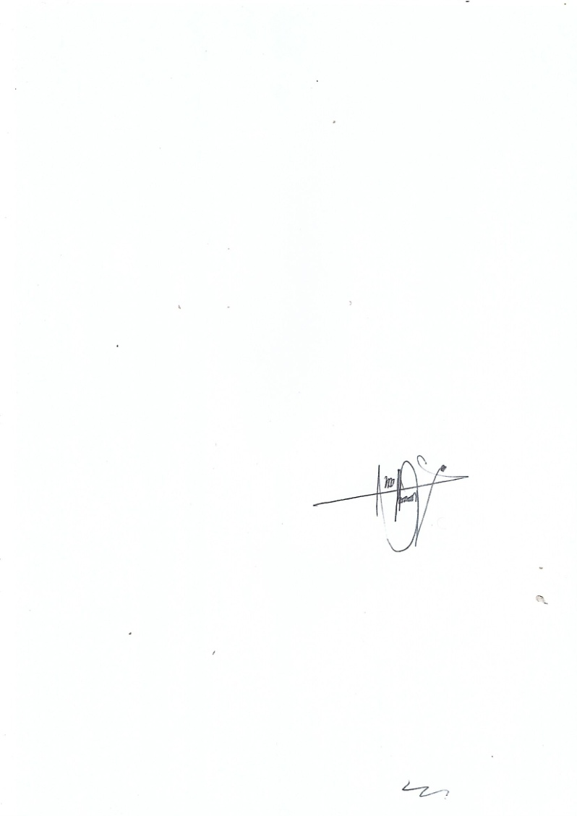

Paul K. Arhin Jnr

(Department Industrial Liaison Officer)